Descent of the Holy Spirit Ukrainian Catholic Church  44 Sugarloaf Street South Deerfield, MA 01373  Pastor Fr. Andriy Krip phone: (413) 583-2140  November 23, 2025 Tone 7  Glory to Jesus Christ!- Glory now and Forever!  Schedule of Divine Liturgies  10:10 Rosary prayer  Sunday November 23 – 10:30 Divine Liturgy for health and spiritual wellbeing of all parishioners and growth of the Descent of the Holy Spirit Parish  (24th Sunday after Pentecost)  Epistle: Eph. 2:14-22  Gospel: Lk. 12:16-21  Pray for the end of Russian aggression in Ukraine  Happy and Blessed Thanksgiving to you and your families  10:10 Rosary prayer  Sunday November 30 – 10:30 Divine Liturgy for health and spiritual wellbeing of all parishioners and growth of the Descent of the Holy Spirit Parish  (25th Sunday after Pentecost)  Epistle: Eph. 4:1-6  Gospel: Lk. 13:10-17  Prayer Corner  Support request  Dear parishioners of the Descent of the Holy Spirit as we all face those difficult times all may have financial difficulties and our parish is at the point to face the financial difficulty as well. We need your support to be able to pay the parish bills. Our yearly bazaars were big chunk of parish expenses, but this year we were not able to do them. Those who may have ideas how to raise funds please bring up those ideas.  Receiving HOLY EUCHARIST  Holy Eucharist – Body and Blood of Jesus Christ (Holy Communion) – is one of the seven Sacraments. It has to be received worthily for the salvation of our soul. Holy Eucharist is not just representation of the Body and Blood of Jesus Christ but after the Consecration becomes the Body and Blood of Jesus Christ. When preparing ourselves for the receiving of the Holy Eucharist we should examine our conscience and make sure if we do not have any mortal sins. (In case of mortal sin we need to have the Sacrament of Confession). Make act of contrition for all your venial sins and then with reverence receive Holy Eucharist.  Preparation for the Sacrament of Confession  Please use the handouts for the preparation of the confession. | Receiving HOLY EUCHARIST  Holy Eucharist – Body and Blood of Jesus Christ (Holy Communion) – is one of the seven Sacraments. It has to be received worthily for the salvation of our soul. Holy Eucharist is not just representation of the Body and Blood of Jesus Christ but after the Consecration becomes the Body and Blood of Jesus Christ. When preparing ourselves for the receiving of the Holy Eucharist we should examine our conscience and make sure if we do not have any mortal sins. (In case of mortal sin we need to have the Sacrament of Confession). Make act of contrition for all your venial sins and then with reverence receive Holy Eucharist  Upcoming events  November 15 – Beginning of fast in preparation for Christmas  Bishop’s Appeal  Please be generous for this collection. May God bless you for your generosity.  Fr. Andriy and Mrs. Olga Krip $100; Mr. Myron Chudzik $200; Mr. Ladimer and Mrs. Anna Nagurney $100; Mr. Roger Giffin $300  Collected: $700  Goal: $700  Monthly collection goal: $4194  January; February; March collected $7781 short $ 4801  April; May; June: collected $12964 short $ 382  July; August; September: $ collected $ 8722 short $ 3860  October collected:$ 16954 met goal by $ 12760  November 16 Collection  Plate: $ 270 Candles: $27 Other $  Total $297  May God Bless You ALL!  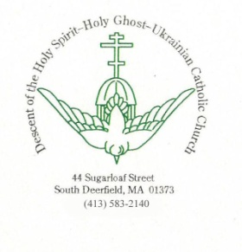  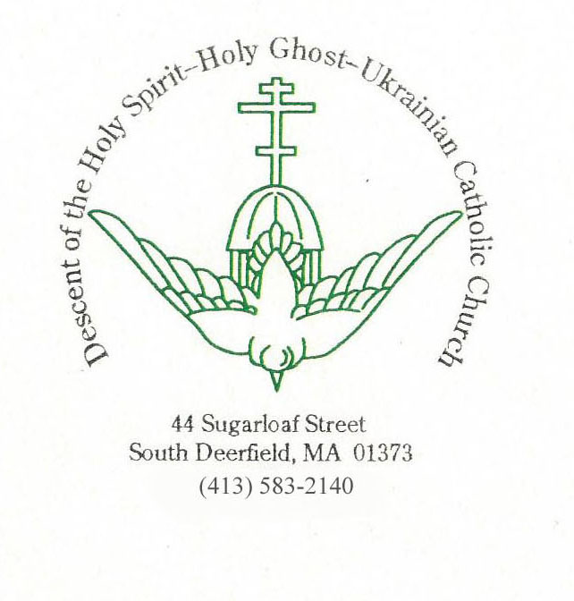
  Please keep in your prayers: | Mr. Arnold Filipi; Mr. Yaroslav ad Mrs. Alla Leshko; Mrs. Patricia Robinson and her husband; Mr. Chuck and Mrs. MaryJeanne Perlmutter; Niko and Maria Sinodinos,

